How to use our Website to Submit Documents to us



Training Manual

For SMSF Trustees
Name of the firm
Address of the firm
Contact Details of the Firm

Contents

Accessing the System 3
Change Access Details 3
Uploading Documents for current year 5
Notification to us that Documents have been uploaded 8
Progress of Audit 8
Our (Auditor’s / Accountants) Query 8
Responding to our (Auditor’s / Accountants) Query 9
Accessing & Downloading Previous Years Documents 12
Support/ Feedback 16

Accessing the System

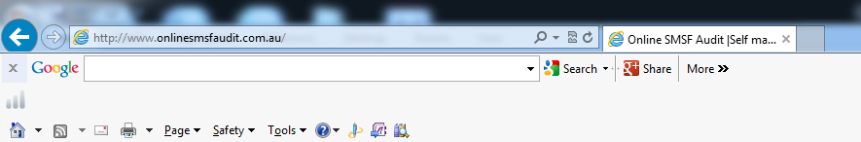
Your Webiste Address

- To visit the website, please type <Your website address> into your browser.
Put Screen Shot of your website

- We should have your access details (username and password) to access the system. If you have not received these access details contact us. Once you have logged on you can change your password.

- Once you are logged on, you will be taken to a document manager page. This is the main interface where you can provide documentations, view the progress of audits, upload documents, address any query and obtain reports.

- Once you log in you land on “Document Manager” page.

Change Access Details

You can change/update your password by following these steps.
- On ‘Document Manager’ page, click on ‘Change Details’ button on top left hand side corner. This will take you to ‘Change Details’ page.
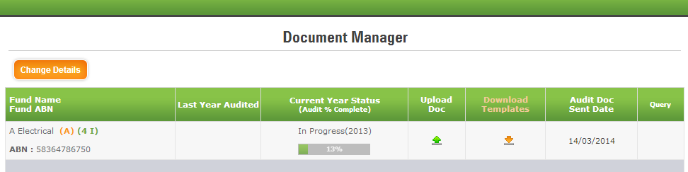

- On ‘Change Details’ page, click on ‘Change Password’ link. This opens up a pop-up window ‘Change Password’.

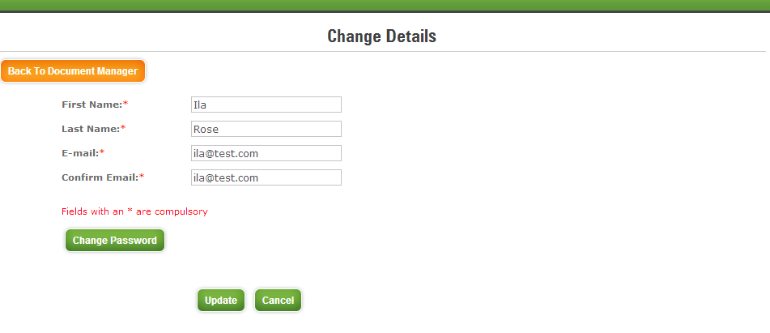

- Change your password by entering ‘Current Password’, ‘New Password’ and ‘Confirm Password’ fields and click on ‘Update’ to update your password.
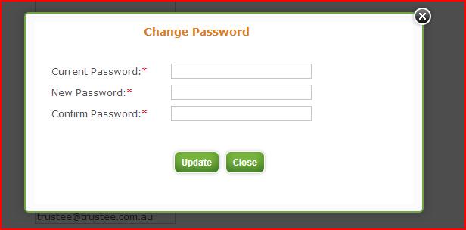

Uploading Documents

- To upload documents, On ‘Document Manager’ page click on ‘Upload Doc.’ icon You will be directed to document upload page.

- To upload SMSF permanent documents:
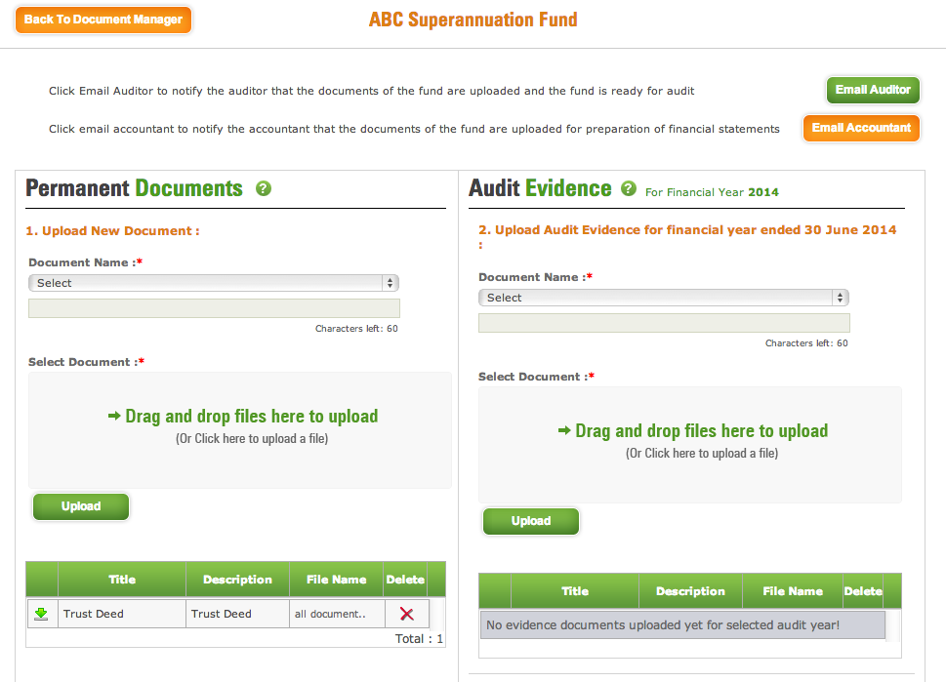
1
3
2
- Select “Title” of the document from the drop down list ‘Document Name’ under Permanent Documents section. On the second line you can enter your own Description
- Click on ‘Click here to upload a file’ and select the file to be uploaded or you can simply drag and drop files to upload.
- Click on ‘Upload’ to upload the permanent document.
- If you do not find the title of the permanent document in the drop down list, select the last item ‘Other’ and provide the description of the document in the field below the drop down list.
- Repeat step 2 and 3
- Repeat until all permanent documents are uploaded – you can drag and drop up to maximum10 files before you can click on upload button.
- Once you upload the document – the table below gets populated with documents uploaded by you.

- To upload audit evidence for the financial year:

- Upload Audit Evidence just the same way as uploading Permanent Documents
- Upload only documents which pertain for that financial year.
- For further clarification for types of documents we have further sub-divided the document headings as under
  - Financial Statements
  - Supporting Income & Expenses
  - Investments
    - Bank Balances
    - Listed Shares & Units & Unlisted Shares & Units
    - Managed Funds and wrap accounts
    - Real Property
    - Other Assets
  - Member Accounts and Pension Documents
  - Fund Administration
  - Other If you do not find the title of the “Audit Evidence” document in the drop down list, select the last item ‘Other’ and provide the description of the document in the field below the drop down list.
- If you upload documents separately, e.g. Westpac dividend separately to BHP dividends Click on ‘Click here to upload a file’ and select the file to be uploaded OR you can simply drag and drop files to upload.

- To Upload data from accounting software:

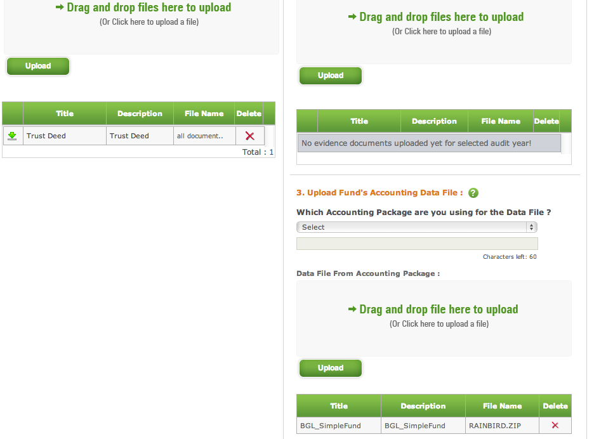
- Select the Accounting package that you are using to administer your SMSF.
- Click on ‘Click here to upload a file’ button and select the data file to be uploaded OR you can simply drag and drop file to upload.
- Click on ‘Upload’ button to upload the data file.
Notification to us that Documents have been uploaded
Click on ‘Email Auditor’ or ‘Email Accountant’ after uploading required documents. An email will be sent to Auditor/Accountant informing them about the completion of documents upload.

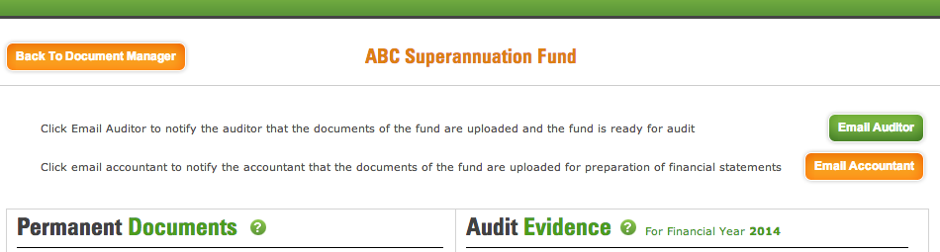

Progress of Audit

You can see progress of super fund audit as % complete in ‘Current Year Status’ column on ‘Document Manager’ page.

Our Queries to you (Accountant / Auditor’s) Query

When the auditor needs some more information or a document from you, he will raise a query from his end. Once he raises a query for you, you can see on the ‘Document Manager’ page, a red coloured query icon will appear in ‘Query’ column.

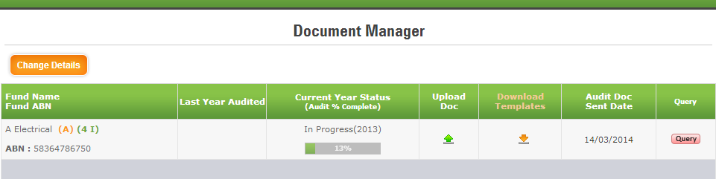

Once you respond to the query, the query icon colour will change to green indicating that you have responded to the queries raised by us (auditor / accountant).

Responding to Auditor’s Query

- You can respond to a query raised by auditor by clicking on icon on ‘Document Manager‘s page.

- Query dashboard for the super fund pops-up.

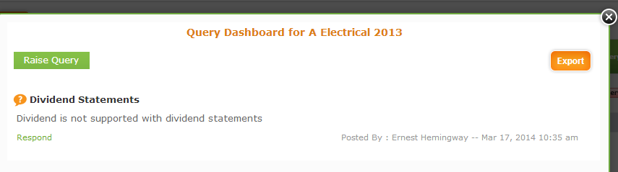
- To answer to the query – click on the Respond text above. To enter your response in the Response text area.

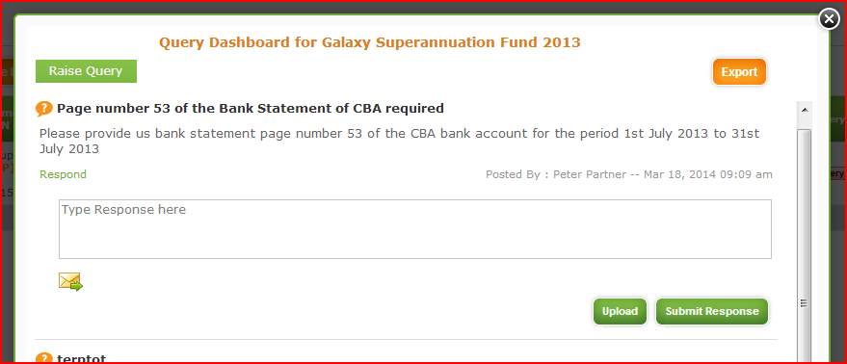
- Type in your response in the response area provided and clicks the “Submit Response” button.

- To upload documents, to be included in response to the query, Click on ‘Upload’ button.

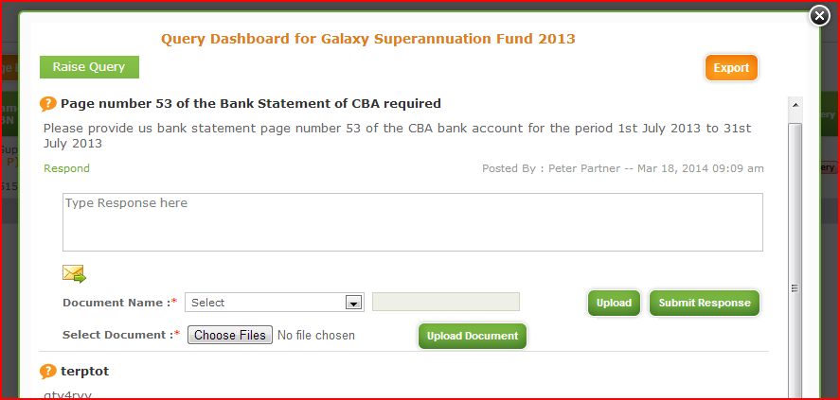

- Select a document name from drop down list.
vii
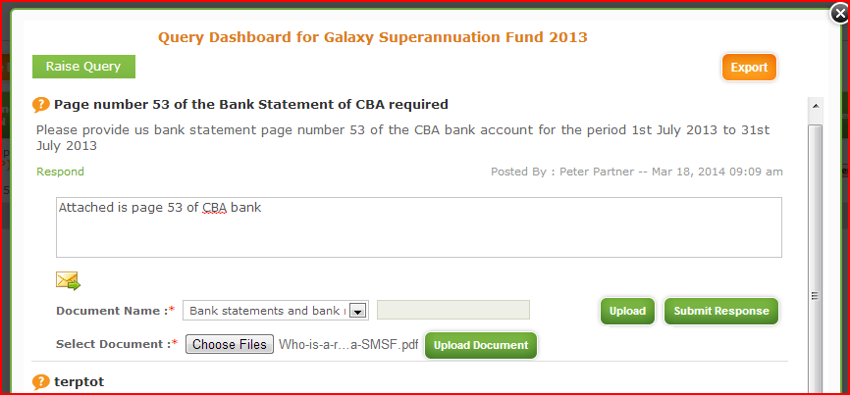
iv
v
vi

- Click on ‘Choose Files’ to select file to be uploaded and click on ‘Upload Document’.
- Click on ‘Submit Response’ to respond to the query raised by auditor.
- Please note that to send and email out to the auditor you need to click this button.
- Once you have Click on the ‘x’ at the top of the dashboard to close the queries dashboard and return to document manager page.
- The query button should now be green.

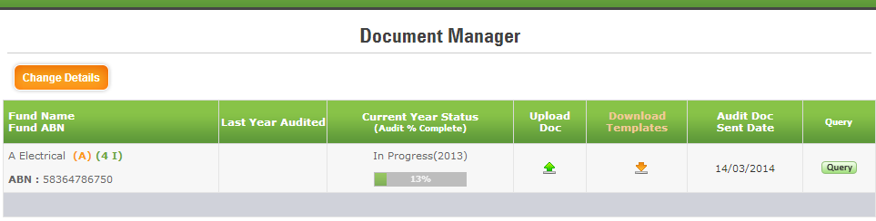
viii

Accessing Previous Year Audit Working Papers

We may ask you to download some documents for the fund which has been audited and upload some of these documents of previous year after your signature.
- On ‘Document Manager’ page click the year in Last Year Audited column against your fund name to go to ‘Last Year Audits’ page.
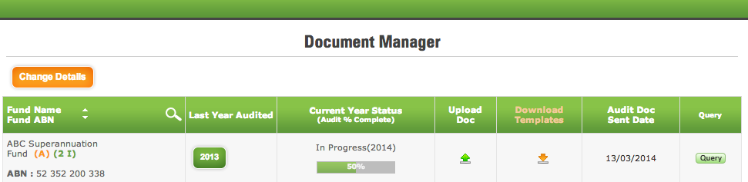

- To download Permanent Documents On ‘Last Year Audits’ page, click on ‘Download Permanent Document’ link and proceed to step 4 onwards.

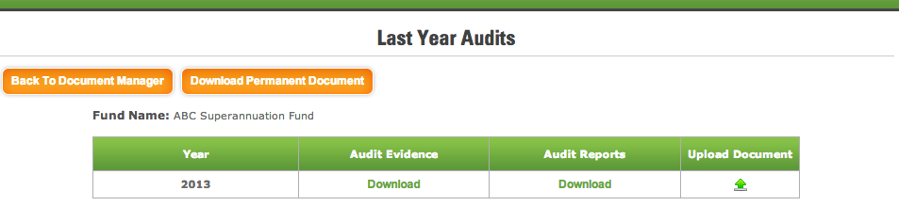
- To Download Audit Evidence and Audit Reports On ‘Last Year Audits’ page, click on download link below the Audit Evidence and Audit Reports column.
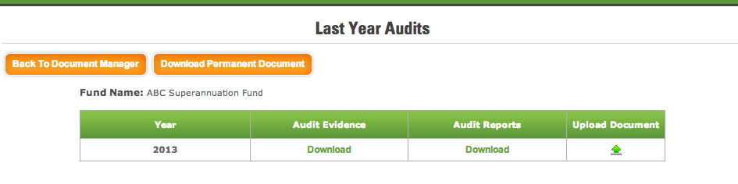

- A pop-up window will appear with the list of documents for the fund.

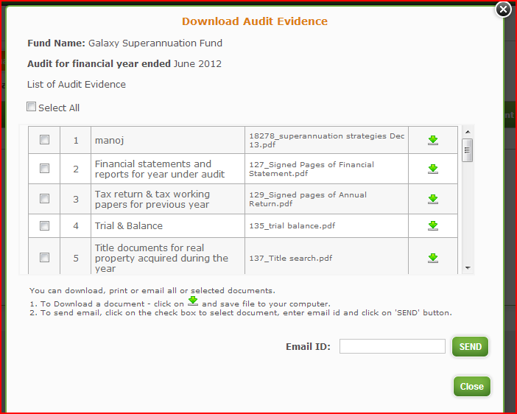

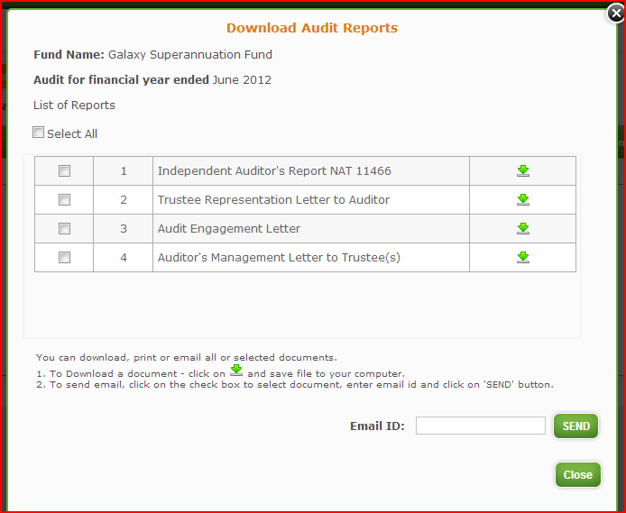

- If you want to keep a copy of these documents Click on the check box to select the relevant document(s) required - To email the document(s) to yourself of someone else, enter the email id to which the document(s) need to be sent and click on ‘Send’. An email will be sent to the email id entered with selected document(s) attached.

- To download and view the document(s), click on icon in the row of the document that you would like to download.

- We may also request you to download some templates and upload them in last year audits. To download a template click from the Document manager

And the following window will open up

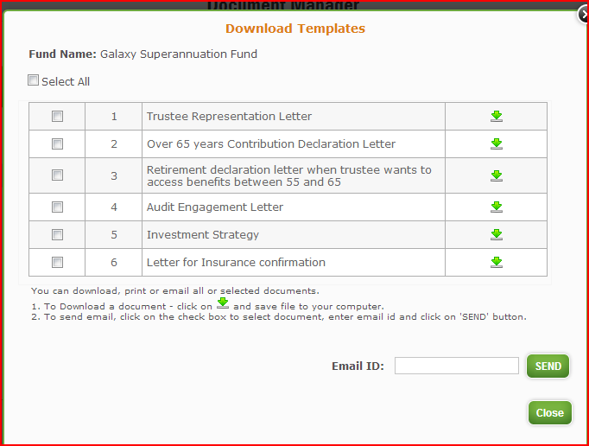

To download any template or email it to anyone, follow the procedure mentioned above. After singing the template, ensure that you upload the document in the correct year, which can be either be previous year where the audit is completed or the current year where the audit is being conducted. Some templates need to be uploaded every year.

- To download documents of previous year and then signing those documents and uploading them in the previous year, click the upload button

The same upload documents screen comes up – and uploading documents procedure is the same as mentioned above - BUT note that this time you are uploading documents in the year where the audit is already complete

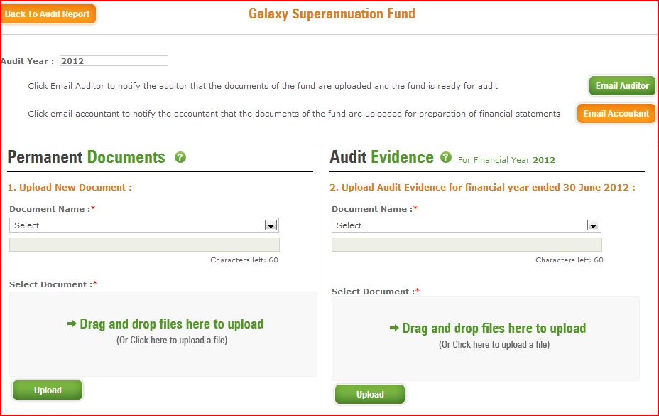

Support/ Feedback

We are available to help at every step of the process; you can also call us on the number given on our website.

You can also forward your queries or request for any assistance to our email address. We will endeavour to respond to your email within a day.

Ver 1.3 18th March 2014

